**Name: Laiba Gul**

**Class: BS CS (7th)**

**SapId: 55740**

**Class Task**

**Question N0:01**

**Code**

.MODEL SMALL

.STACK 100H

.DATA

MSG1 DB 'Enter any two digit number: $'

MSG2 DB 0DH, 0AH, 'Reversed Number: $'

NUM DB ?, ?, '$'

.CODE

MAIN PROC

MOV AX, @DATA

MOV DS, AX

MOV DX, OFFSET MSG1

MOV AH, 09H

INT 21H

MOV AH, 01H

INT 21H

MOV BL, AL

MOV NUM, AL

INT 21H

MOV BH, AL

MOV NUM+1, AL

MOV DX, OFFSET MSG2

MOV AH, 09H

INT 21H

MOV DL, BH

MOV AH, 02H

INT 21H

MOV DL, BL

MOV AH, 02H

INT 21H

MOV AH, 4CH

INT 21H

MAIN ENDP

END MAIN

**Output:**

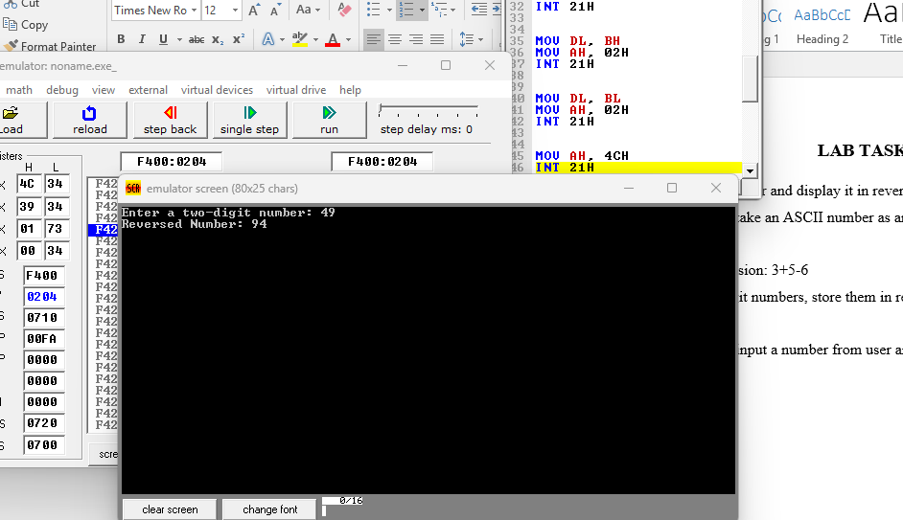

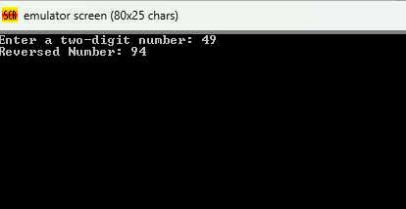

**Question NO:03**

**Code**

.model small

.stack 100h

.data

result_msg db 'The result is: $'

result db ?

newline db 0Dh, 0Ah, '$'

.code

main:

mov ax, @data

mov ds, ax

mov es, ax

; Evaluate 3 + 5 - 6

mov al, 3

add al, 5

sub al, 6

mov result, al

; Display

lea dx, result_msg

mov ah, 09h

int 21h

; Display

mov al, result

add al, 30h ; number to ASCII

mov dl, al

mov ah, 02h

int 21h

lea dx, newline

mov ah, 09h

int 21h

mov ah, 4Ch

int 21h

end main

**Output:**

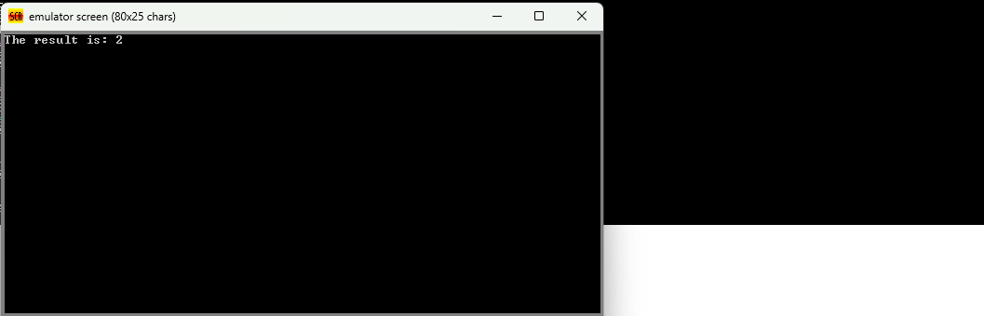

**Question NO: 04**

**Code**

.model small

.stack 100h

.data

prompt1 db 'Enter first single-digit number: $'

prompt2 db 0Dh, 0Ah, 'Enter second single-digit number: $'

result_msg db 0Dh, 0Ah, 'After swapping: $'

newline db 0Dh, 0Ah, '$'

.code

main:

mov ax, @data

mov ds, ax

mov es, ax

lea dx, prompt1

mov ah, 09h

int 21h

mov ah, 01h

int 21h

sub al, 30h

mov bl, al

lea dx, prompt2

mov ah, 09h

int 21h

mov ah, 01h

int 21h

sub al, 30h

mov bh, al

xchg bl, bh

lea dx, result_msg

mov ah, 09h

int 21h

s

mov al, bl

add al, 30h ; Convert to ASCII

mov dl, al

mov ah, 02h

int 21h

mov dl, ' '

mov ah, 02h

int 21h

mov al, bh

add al, 30h

mov dl, al

mov ah, 02h

int 21h

lea dx, newline

mov ah, 09h

int 21h

mov ah, 4Ch

int 21h

end main

